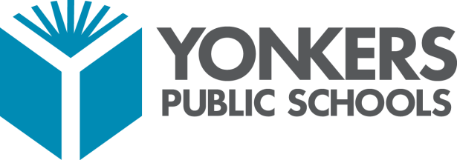

**How to Sign into Clever**

1. **Go to: clever.com/in/yonkers** from any internet-enabled device or click on the **Clever Tab** on your School’s Website.
2. On a school laptop click the Clever Icon 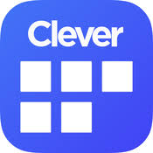 .

**Login to YPS Instructional Technology Resources on Clever**

* For library resources that require different login credentials, hover over the “?” to display the username and password.
* Use the displayed username and password to access the resource.

# 3. Yonkers Public School District

# Login - Typing Agent

**Logging in through Clever** = student ID@yonkerspublicschools.org and

your password = Date of Birth (MMDDYYYY). **Example:** (09082020).

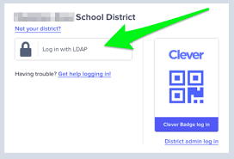

**Logging in through LDAP** = student ID@yonkerspublicschools.org and your most recent **computer password.**